Design and Methodology

The beginning of our project, our group decided to find solution to a problem that would help the students at school. We got the idea of helping the students with attention disorders to stay focused and be in the current in class. This was very important to us because of our personal experiences. A friend of mine suffers from this condition making her set back in school work, affected her life every day and someone has to constantly remind her to get back on task. The solution had to be an object that would remind the user to get back to work. Our group came up with a device that would buzz every few seconds to help the user. The problem with this was that if the user was already focused and working on their task, it would distract them. We also wanted to incorporate this idea into an everyday school material so it would be easier to carry around and the user won’t leave it behind. After lot of brain storming about different devices we concluded that our final solution was to put the device in a pen. This is a perfect idea because it would solve the problem of random buzzing with a set timer automatically triggered when the pen is not in use. This is also a school material that one wouldn't be left behind.

The prototype was manufactured by taking a normal pen and cutting off the end of the inkwell and putting a dowel of wood in its place to represent the vibrating element. There was also a small extrusion of wood glued to the inkwell to push the button. The cap of the pen was altered as well with an extrusion on the inside to push the inkwell up when not in use. The vibrating element is setup in a circuit with a button and a timer to set it off. We have designed and tested several prototypes to make sure that the final design meets all the required design specifications and the outlined functionalities of the device. The major functional features include, the timer to identify the idle time with the ability to set the idle time. If the user uses the pen before the idle time reaches, it should reset and wait for the next idle time to trigger when it meets the specified timer. When the vibration is triggered, user should be able to reset it quickly not to distract or irritate the user.

We build many prototypes along the following guidelines. We have identified all the variables in design and the corresponding dependent factors to make sure that the design works. This gave us opportunity to try out and design different models of the device. These include the spring design to accommodate different user styles of writing and force being used. Second, idle timer, vibration circuits design and incorporating into the design for improvement of the product usage.

The testing for each prototype was to test how the pen held up by being pressed many times to see if the timer resets as it is being used. The springs used should match with the different user styles of writing to create enough impact to set or rest the timer with push of the button arranged. We also capped the pen to see if the well raised enough to shut off the mechanism. The timing circuit was also tested to see if it properly lasted for about a minute before going off. For each model we developed a set of test scenarios and test steps. We have multiple testers carrying the testing at various stages like unit testing, QA testing by a team of qualified testers / users and recorded the test results in an excel sheet with pass / failure information along with the exact nature of failure.

We have followed iterative design approach. First we have most of the mechanical components like sprints, mechanical buttons and electronic chips for idle timer and vibration circuits. As these are bigger in size we wanted to remove mechanical components with electronic sensors to identify the use / nonuse of the pen with set broad range of parameters.

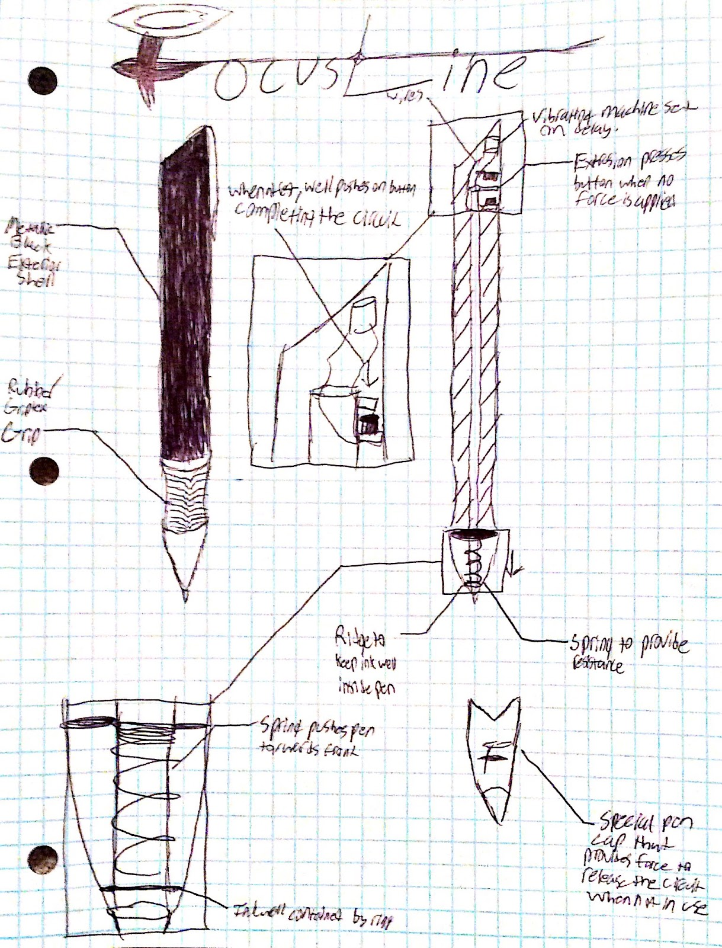

Conclusion

The end goal was to create a device that would help the students with attention disorders, and it was accomplished. There is no product out there with the same purpose as FocusLine. The Asian product was similar to ours in design but it had a different and opposite reason. It was designed to remind students to take a break from work. It isn’t necessarily better than ours but it is very similar to ours. Our first idea was to build a complete circuit inside the pen with wires, switches and a timed vibrator. Then we realized that all these materials wouldn’t fit in the small pen so we had to come up with a different design. The new ideas were to design a timer and vibrating circuits which fits in the design models of ours. Another idea is to use the latest technologies to fit the complete mechanism in the inkwell without any springs to identify the pressure range and automatically sets the idle timer and vibration. This reduces the complexity in design replacing with all electronic chips. The problem currently is the timed vibrators, that were going to reduce the size of the design and help fit in the pen, can’t be found online. This is the problem that we are trying to fix now.

This product can be sold. Hopefully one day FocusLine can be a sold at an office supply store. The pen is not a very expensive product, because the materials that are used to make it are low cost material or electronic chips. We are currently working the enhancements to the current design of the overall product to make it attractive, useful and robust bringing technological advancements. The name of the product is already decided and its FocusLine. The name was chosen because of its purpose to make people focus on their task. The design for the pen is just the look of a normal pen.

Acknowledgements

A very big thank you to Mr. Devaraju Yetukuri for his help in understanding me the importance of multiple prototype design importance and testing procedures. A big thanks my colleagues for making this project sessions more enthusiastic and interesting during discussions and prototype development.